

Department of Software Engineering

**EMBEDDED SYSTEM DESIGN (LAB)**

**Traffic Light Control System**

**Group Members**

|  |  |
| --- | --- |
| **Uzair Mehmood** | **51739** |
| **Hammad Shaikh** | **51717** |
|  |  |
|  |  |

**BSE-6A**

**Spring 2020**

**Submitted to**

**Engr. Syed Zia Uddin**

Table of Contents

1. Abstract 1

2. Introduction 1

3. Literature Review 2

4. Components and Tools Description. 3

5. Block Diagram/Flow Chart 4

6. Methodology 4

**6.1. Proposed Model………………………………………………………4**

**6.2 Circuit/ Simulation Diagram......................................................…....5**

**6.3 Circuit / Simulation Description……………………………………..5**

7. Results and Discussions 6

8. Conclusion and Future Work 6

9. Project Summary 7

10. Project Pictures 8

11. References 9

1. **ABSTRACT**

In day to day life problem of traffic congestion is faced by every individual. As count of vehicles is increasing on road this severe traffic congestion is increasing rapidly in cities. This project proposed new solution to traffic control. The main design concept of this project is to control the traffic signals. Controlling traffic signal independent of intensity of vehicle on road is on of basic projects. In prototype prepared for controlling of traffic we are using red, green and yellow color LED’s. Delay can only be controlled through code. This project is implemented using Arduino UNO microcontroller.

1. **INTRODUCTION**

Traffic lights, developed since 1912, are signaling devices that are conceived to control the traffic flows at road intersections, pedestrian crossings, rail trains, and other locations. Traffic lights consist of three universal colored lights: the green light allows traffic to proceed in the indicated direction, the yellow light warns vehicles to prepare for short stop, and the red signal prohibits any traffic from proceeding.

Nowadays, many countries suffer from the traffic congestion problems that affect the transportation system in cities and cause serious dilemma. In spite of replacing traffic officers and flagmen by automatic traffic systems, the optimization of the heavy traffic jam is still a major issue to be faced, especially with multiple junction nodes. The rapid increase of the number of automobiles and the constantly rising

number of road users are not accompanied with promoted infrastructures with sufficient resources. Partial solutions were offered by constructing new roads, implementing flyovers and bypass roads, creating rings, and performing roads

rehabilitation.

However, the traffic problem is very complicated due to the involvement of diverse parameters. First, the traffic flow depends on the time of the day where the traffic peak hours are generally in the morning and in the afternoon; on the days of

the week where weekends reveal minimum load while Mondays and Fridays generally show dense traffic oriented from cities to their outskirts and in reverse direction. respectively; and time of the year as holidays and summer.

Secondly, the current traffic light system is implemented with hard coded delays where the lights transition time slots are fixed regularly and do not depend on real time traffic flow. The third point is concerned with the state of one light at an

intersection that influences the flow of traffic at adjacent intersections. Also, the conventional traffic system does not consider the case of accidents, roadworks, and breakdown cars that worsen traffic congestion. In addition, a crucial issue is

related to the smooth motion through intersections of emergency vehicles of higher priorities such as ambulances, rescue vehicles, fire brigade, police, and VIP persons that could get stuck in the crowd. Finally, the pedestrians that cross

the lanes also alter the traffic system. The conventional traffic system needs to be upgraded to solve the severe traffic congestion, alleviate transportation

troubles, reduce traffic volume and waiting time, minimize overall travel time, optimize cars safety and efficiency, and expand the benefits in health, economic, and environmental sectors. This paper proposes a simple, low-cost, and real time smart traffic light control system that aims to overcome many defects and improve the traffic management. The system is based on PIC microcontroller that controls the various operations, monitors the traffic volume and density flow via infrared sensors (IR), and changes the lighting transition slots accordingly. Moreover, a handheld portable device communicates wirelessly with the traffic master controller by means of XBee transceivers in order to run the appropriate subroutines and allow the smooth displacement of emergency vehicles through the intersection.

1. **LITERATURE REVIEW**

Signalized traffic control has significant effect on reducing vehicle delays at intersections, balancing traffic flow, and improving operational efficiency of an urban street network. The intersection signal control systems can be largely classified into fixed-time or real-time adaptive signal control systems, such as SCAT and SCOOT The modeling of the intersection signal control system is usually based on the changes of traffic volumes. In past days the use of fixed time traffic signal and vehicle actuated traffic signal is more. Now a days many other techniques are used to optimize delay and to control traffic flow, adaptive traffic signal controllers are one of them to optimize traffic signal, different types of algorithms are used to make best adaptive traffic signal controllers, different type of algorithms are highlights of this paper.

1. **COMPONENTS AND TOOLS DESCRIPTION**

3WATT330R:

These resistors are used between 7- Segment and Arduino UNO pins.

7-SEGMENT DISPLAY CATHODE GREEN:

This is green led seven segment cathode display used to display timer.

TRAFFIC LIGHT:

Traffic light is component in proteus that contain red yellow and green lights.

ARDUINO UNO:

The Arduino Uno is an open-source microcontroller board based on the Microchip ATmega328P microcontroller and developed by Arduino.cc

BUSES:

When designing your circuit in Proteus, it can be difficult to manage if there are too many connections. Tedious editing is avoided by drawing each of the address and data buses as a single pin.

PROTEUS:

The Proteus Design Suite is a proprietary software tool suite used primarily for electronic design automation. The software is used mainly by electronic design engineers and technicians to create schematics and electronic prints for manufacturing printed circuit boards.

ARDUINO:

The open-source Arduino Software (IDE) makes it easy to write code and upload it to the board. It runs on Windows, Mac OS X, and Linux. The environment is written in Java and based on Processing and other open-source *software*.

1. **BLOCK DIAGRAM**

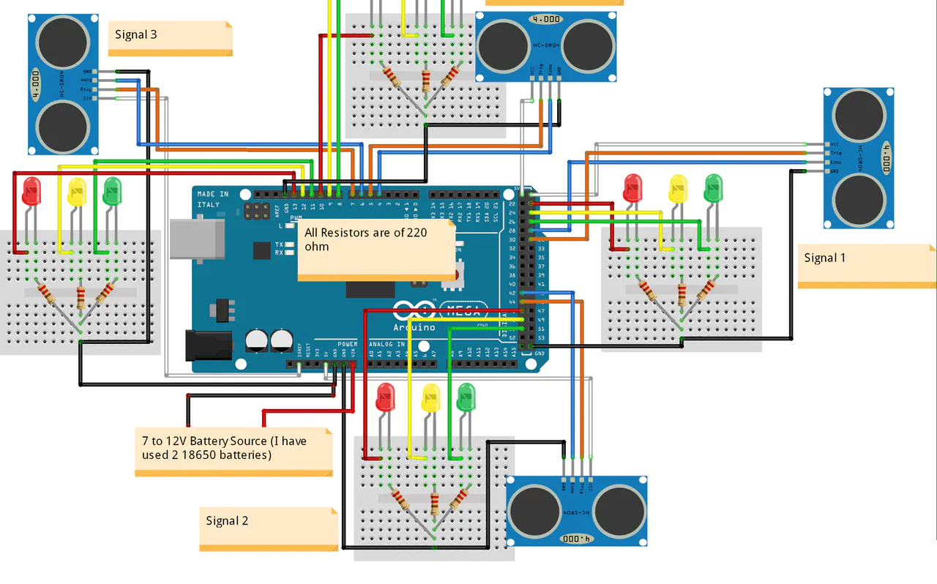

1. **METHODOLOGY**
   1. **Proposed Model**

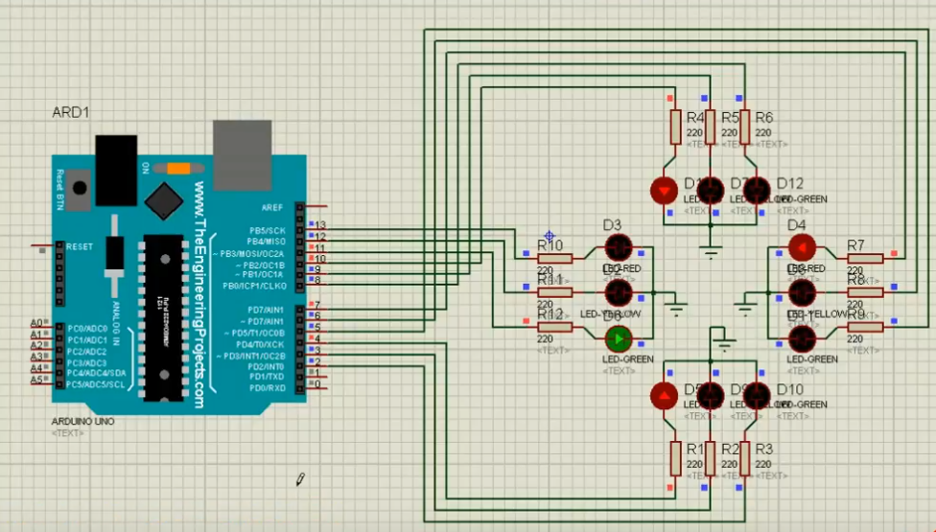

* 1. **Circuit / Simulation Diagram**

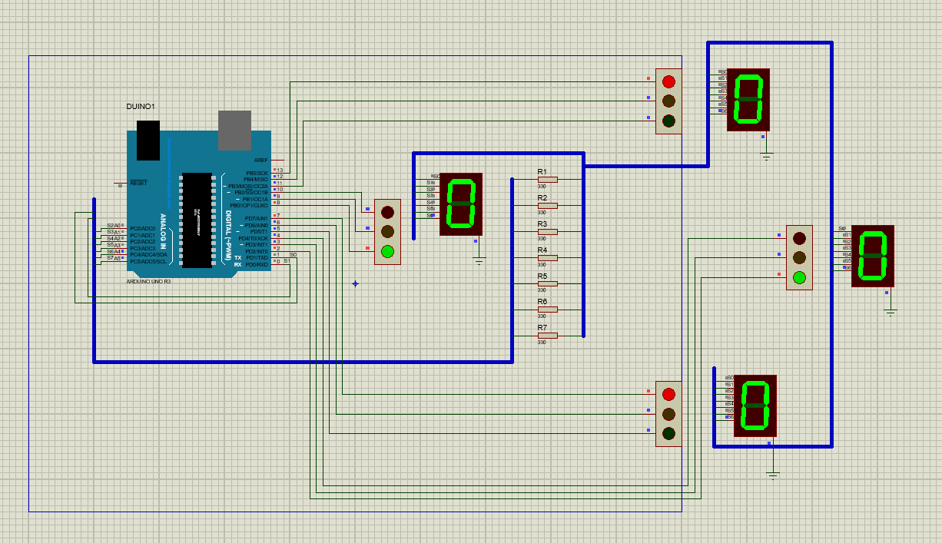

* 1. **Circuit / Simulation Description**

Traffic signal 1 is connect with pin 11,12 and 13 of Arduino UNO. Traffic signal 2 is connect with pin no 8,9 and 10 of Arduino UNO. Traffic signal 3 is connect with pin no 5,6 and 7 of Arduino UNO. Traffic signal 4 is connected with pin no 2,3 and 4 of Arduino UNO. Remaining 7 pins 0,1,14,15,16,17,18,19 and 20 of Arduino UNO are used for seven segment display. There are 4 seven segment displays. All seven 7-Segment displays are connected with the buses. Bus is connected with seven pins of Arduino in between 7 segment and Arduino pins I have used 330-ohm resistors. Pins with bus are labelled as S0, S1, S2, S3, S4, S5, S6. Cathode of 7-Segment is grounded.

1. **RESULTS AND DISCUSSIONS**

As soon as power supply is restored, the 4 junctions give red light as a standard  
procedure. Explanation shows the cycle flow of Normal Mode operation. When the start button is pressed, first junction gives the green light and after a few delays it turns to yellow. After the short delay, it turns to red. Then 2nd junction gives the green light and continues the same step. Complete until 4th junction, then come back to 1st junction and continue the same sequence. In case the power supply cut and restored, this project will give the red light at all junction. Two junction works in parallel at a time as there are total four junctions.

1. **CONCLUSION AND FUTURE WORK**

This project is traffic light control system using microcontroller has been quite successful in controlling traffic congestion. Physical hardware and software are easy to develop. It was simulated on proteus 8 professional. Calculation of yellow light delay is important factor so that driver can stop and get ready within provided delay.

In future IR sensor can be used to detect traffic intensity and control signal based on data provided by traffic intensity. If traffic intensity in high on one signal in automatic traffic light control system the system will increase green light duration on that signal. While decreasing green light duration on signal where there is less intensity of traffic.

1. **PROJECT SUMMARY**

The deployment of light emitting diodes (LEDs) based traffic system control created the problem of dim displays when ambient light is similar to traffic lights. It causes some drivers' disability of seeing and obeying traffic signs. This makes drivers violate traffic rules. In this paper, an attempt to use hybrid lighting technology to mitigate this problem was developed. Incandescent lightings with deployed halogen bulbs provided an instantaneous source of highly efficacious illumination which is brighter than the drivers' ambient lights (both daylight, electrical lights and their reflections), which can help drivers get access to enough warning and help them initiate traffic safety warning as necessary. The halogen lightings also offered the required high current draw needed in electrical circuitry to help brighten the LED displays. The problem of heat generated was eliminated by aerating the T-junction traffic light control unit designed for this technology. The result of hybrid lighting system design was found to be high luminosity and capability of gaining driver attention in real-time. It also allowed enhanced sign's image detection and processing for smart based technologies by providing the “light punch” needed for a wide range of visual concerns.

1. **PROJECT PICTURES**

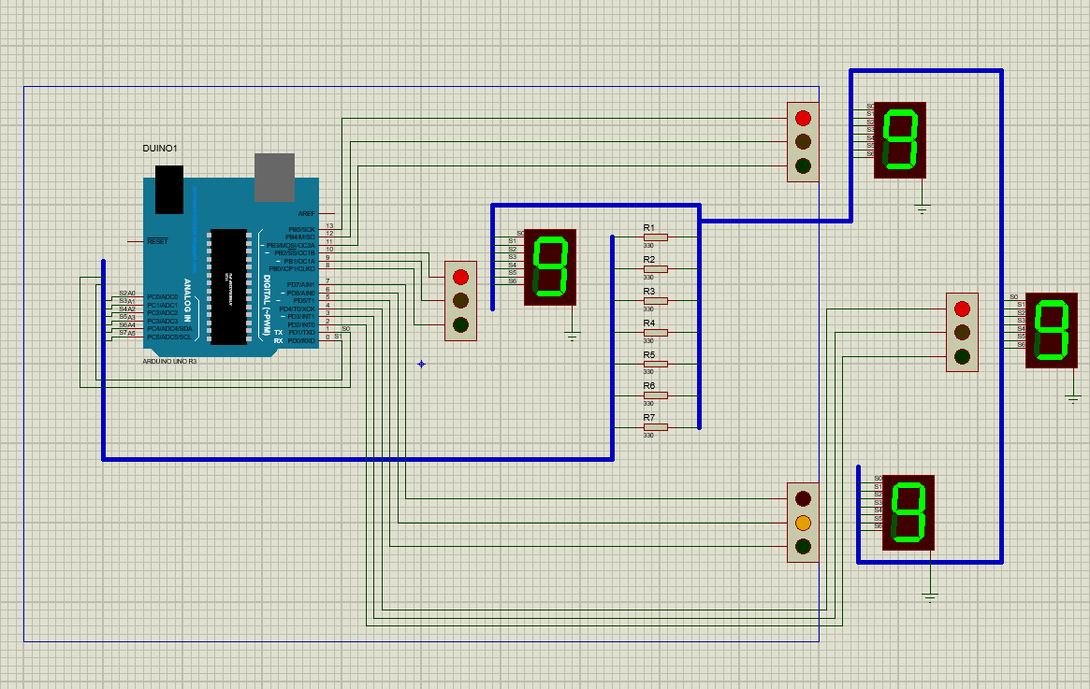

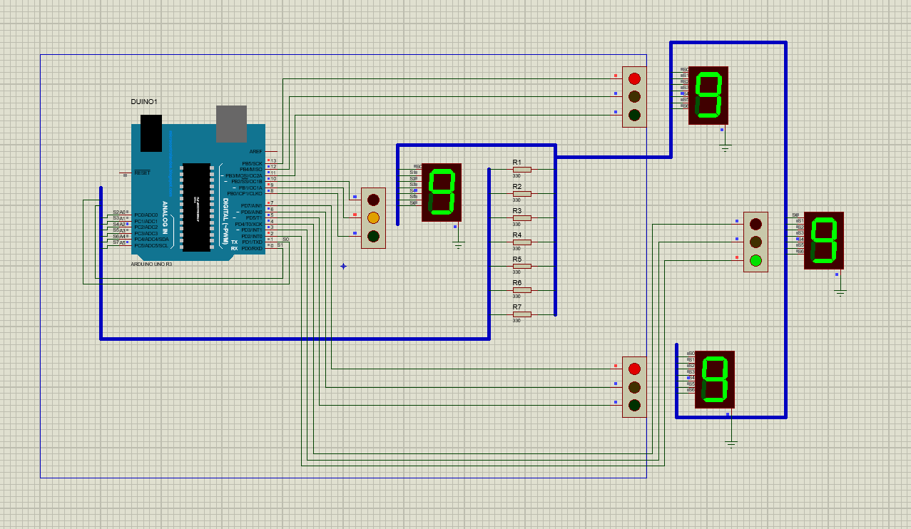

1. **REFERENCES**
2. A. Stevanovic, C. Kergaye, J. Stevanovic, “Evaluating robustness of signal timings for varying traffic flows”, Transp. Res. Rec.: J. Transp. Res.Board (2259) (2011) 141–150.
3. Chandrasekhar.M, Saikrishna.C, Chakradhar.B, phaneendra kumar.p, sasanka.c, “Traffic Control Using Digital Image Processing” ,

International Journal of Advanced Electrical and Electronics Engineering ISSN 2278-8948, Vol.2, May 2013

1. Ekinhan Eriskin, Sebnem Karahancer, Serdal Terzi, Mehmet Saltan, “Optimization of Traffic Signal Timing at Oversaturated Intersections Using Elimination Pairing System”,10th International Scientific Conference Transbaltica 2017: Transportation Science and Technology, Procedia Engineering 187 (2017) 295 – 300
2. Gustav Nilsson _ Giacomo Como, “On Generalized Proportional Allocation Policies for Traffic Signal Control”, International Federation of Automatic Control, 50-1 (2017) 9643–9648,
3. Huajun Chai, H.M. Zhang, Dipak Ghosal , Chen-Nee Chuah, “Dynamic traffic routing in a network with adaptive signal control” , Transportation Research Part C 85 (2017) 64–85
4. Ishant Sharma and Dr. Pardeep K. Gupta, “Study of automatic traffic signal system for chandigarh”, international journal of engineering sciences & research Technology, ISSN: 2277-9655, July, 2015.
5. Jianhua Guo, Ye Kong, Zongzhi Li, Wei Huang, Jinde Cao, Yun Wei, “A model and genetic algorithm for area-wide intersection signal optimization under user equilibrium traffic”, International Association for Mathematics and Computers in Simulation (IMACS), 0378-4754 (2017).

© 2018 JETIR May 2018, Volume 5, Issue 5 www.jetir.org (ISSN-2349-5162)

JETIR1805015 Journal of Emerging Technologies and Innovative Research

1. Junchen Jin , Xiaoliang Ma, “A group-based traffic signal control with adaptive learning ability”, Engineering Applications of Artificial Intelligence 65 (2017) 282–293
2. Mohammad Aslani, Mohammad Saadi Mesgari, Marco Wiering, “Adaptive traffic signal control with actor-critic methods in a real-world traffic network with different traffic disruption events”, Transportation Research Part C 85 (2017) 732–752
3. Naren Athmaraman and Srivathsan Soundararajan, “Adaptive Predictive Traffic Timer Control Algorithm”, Continent Transportation Research Symposium, Ames, Iowa, Iowa State University, August 2005.
4. Nasser R. Sabar , Le Minh Kieu , Edward Chung , Takahiro Tsubota , Paulo Eduardo Maciel de Almeida, “A memetic algorithm for real world multi-intersection traffic signal optimisation problems”, Engineering Applications of Artificial Intelligence 63 (2017) 45–
5. Ramteke Mahesh K., Nikalaje Mahesh J.Prof.D.B.Rane, FPGA implementation of intelligent traffic signal controller based on neuro fuzzy system, International Journal Of Engineering And Computer Science ISSN:2319-7242 Volume 3 Issue 3 March, 2014
6. Rongrong Tian, Xu Zhang, “Design and Evaluation of an Adaptive Traffic Signal Control System – A Case Study in Hefei”, China 2016, International Symposium of Transport Simulation (ISTS’16 Conference), June 23~25, 2016
7. S. Dafermos, Traffic equilibrium and variational inequalitie, Transp. Sci. 14 (1) (1980) 42–54.
8. S.W. Chiou, TRANSYT derivatives for area traffic control optimisation with network equilibrium flows, Trans. Res. B. 37 (3) (2003) 263–290.
9. Shailendra Tahilyani , Manuj Darbari , Praveen Kumar Shukla , “A New Genetic Algorithm Based Lane-By-Pass Approach for Smooth Traffic Flow on Road Networks”, (IJARAI) International Journal of Advanced Research in Artificial Intelligence, Vol. 1, No. 3, 2012
10. Vadrevu S. V. S. R. Pavan Kumar, Dr. M. Kamala kumara, “A Novel Application of Adaptive Traffic Control System for India”, International Journal of Science, Engineering and Technology Research (IJSETR) Volume 5, Issue 7, July 2016, ISSN: 2278 – 7798
11. Prof. Jayesh Juremalani and Dr. Krupesh A. Chauhan, “A Critical Appraisal on Traffic Signal Timing Optimization Techniques Recently Used Worldwide ” International Journal of Futuristic Trends in Engineering and Technology ISSN: 2348-5264 (Print), ISSN: 2348-4071 (Online)Vol. 1 (06), 2014